Staehle Precision Corporation 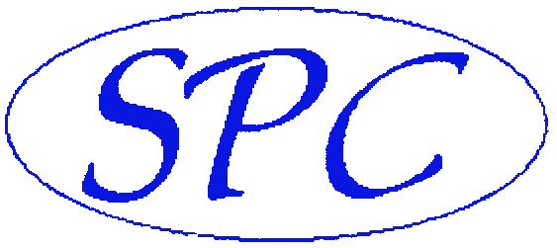
and
Total Machine Service

Together our two Companies offer Machine Tool Laser Calibration and Hard Gauge Calibration Services for ALL types of Machine Tools.
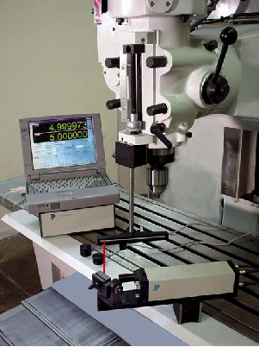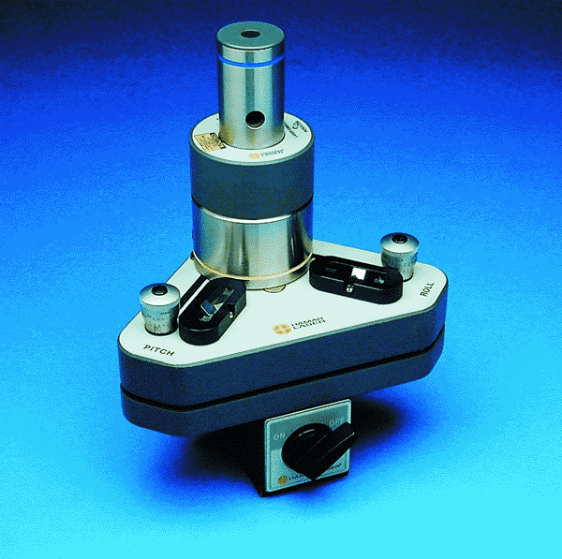
Optodyne MCV 500 LB Laser Hammar L720 Laser
  - We also have a API XD6 58536 Laser and Renishaw Ball Bar QC10
  - 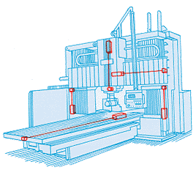
We Calibrate CNC Rotary Tables!
Custom Preventative Maintenance Programs Available
Please call for custom quote for your needs.

Click to see TMS Total Machine Service Brochure
Click to see Staehle Precision Corp. Brochure

